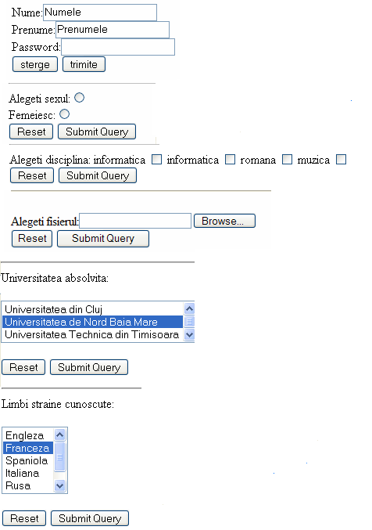

<html>
<head><title>formex_3</title></head>
<body><h1>Un formular cu un buton reset</h1>

<form action="mailto:xxxxx@xxx.com" method="post">
Nume:<input type="text" name="nume" value="Numele"><br>
Prenume:<input type="text" name="prenume" value="Prenumele"><br>
Password:<input type="password" name="parola" ><br>
<input type="reset" value="sterge"> <input type="submit" value="trimite"> </form>

<form action="mailto:xxxxx@xxx.com" method="post">
Alegeti sexul:<br>
Barbatesc<input type="radio" name="sex" value="b"><br>
Femeiesc:<input type="radio" name="sex" value="f"><br>
<input type="reset"> <input type="submit"> </form>

<form action="mailto:xxxxx@xxx.com" method="post">
Alegeti disciplina:
informatica <input type="checkbox" name="informatica" value="informatica ">
matematica <input type="checkbox" name="matematica" value=" matematica ">
romana <input type="checkbox" name="romana" value=" romana ">
muzica <input type="checkbox" name="muzica" value="muzica "><br>
<input type="reset">
<input type="submit"> </form>
<form action="mailto:xxxxx@xxx.com" method="post">
Alegeti fisierul:<input type="file" name="fisier" enctype="multipart/form-data"><br>
<input type="reset"> <input type="submit"> </form>

<form action="mailto:xxxxx@xxx.com" method="post">
Universitatea absolvita:<br><br>
<select name="universitate" size="3"> <option value="B"> Universitatea din Cluj
<option value="UNBM" selected> Universitatea de Nord Baia Mare
<option value="UTT"> Universitatea Technica din Timisoara
<option value="UTB"> Universitatea Technica din Brasov
</select><br><br>
<input type="reset"> <input type="submit">
</form>

<form action="mailto:xxxxx@xxx.com" method="post">
Limbi straine cunoscute:<br><br>
<select name="limbi straine" size="5"> <option value="e"> Engleza
<option value="f" selected> Franceza
<option value="s"> Spaniola
<option value="i"> Italiana
<option value="g"> Germana
</select><br><br>
<input type="reset"> <input type="submit">
</form>

</body>
</html>

